Project Development Phase Model Performance Test

Date | 01 Oct 2026
Team ID | SWTID-2026-4457
Project Name | Script-Controlled ACL – Restrict Record Access Based on Field Value
Maximum Marks

Model Performance Testing:
Project team shall fill the following information in model performance testing template.

S.No. | Parameter | Values | Screenshot
1. | Model Summary | Type: Script-controlled ACL on ServiceNow (rule-based, no ML training). Table: Institution Details  (u_institution_details) with Roll Number,  Student, Faculty, Branch (ECE / EEE / CSE), Email, Phone and Description. Roles: bb1 (read), bb2 (create), bb3  (write), bb4 (delete), assigned to the EEE  User.  Read ACL: Advanced, data condition Branch is EEE, script allows only the bb1 role (admin has full access). | 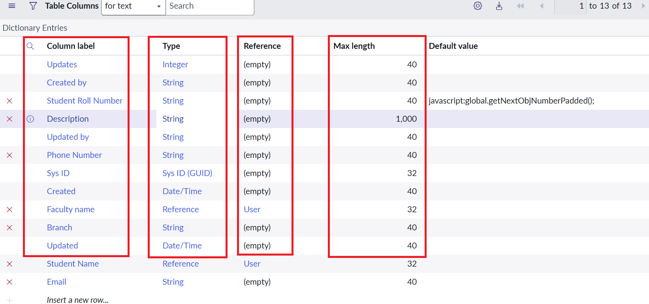  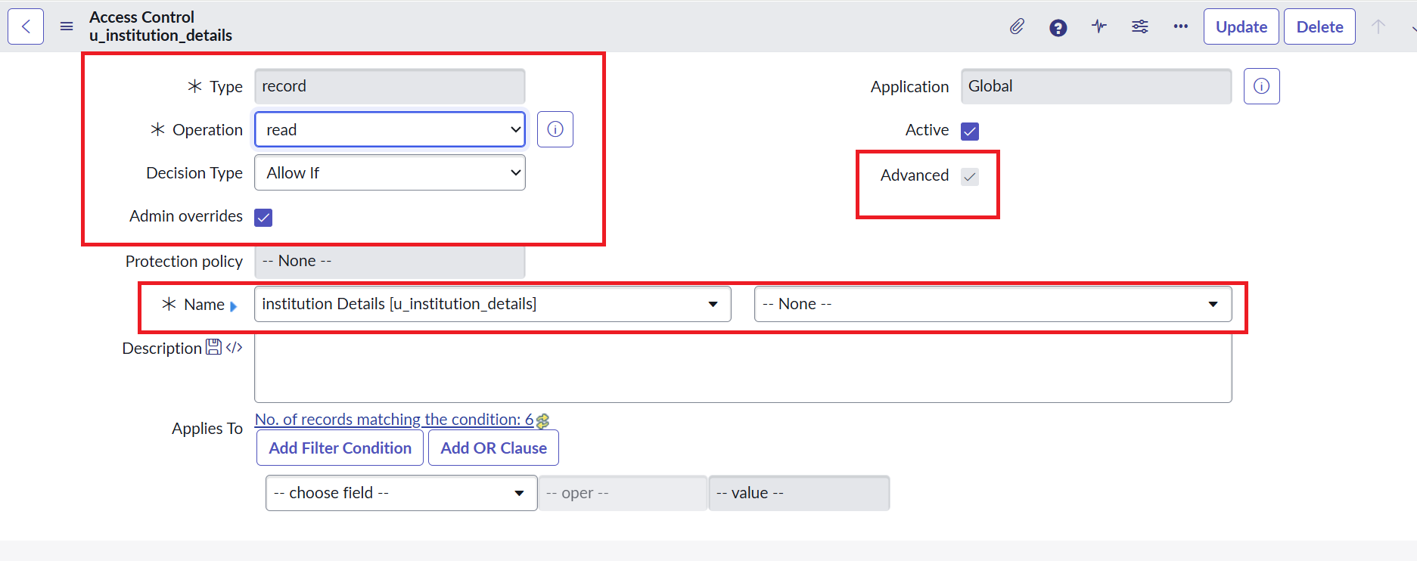
2. | Accuracy | Training Accuracy - N/A (rule-based ACL, no model is trained)  Validation Accuracy - 100% (3 of 3 access scenarios behaved as expected)  - bb1 user sees only the 2 EEE records  - User without the role sees no records  - Admin sees all 6 records | 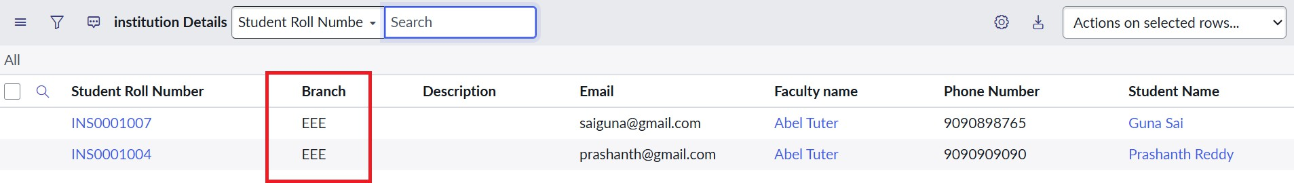  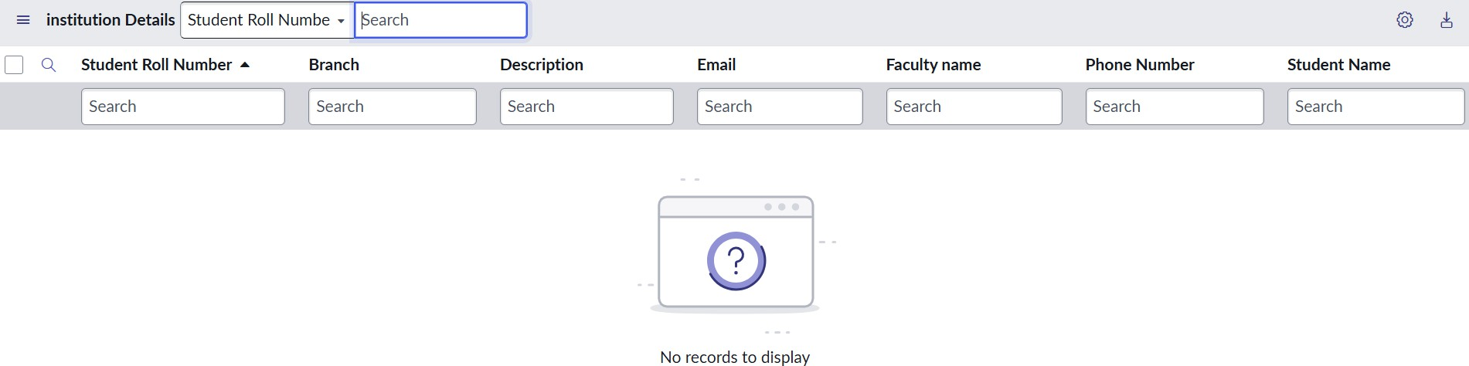  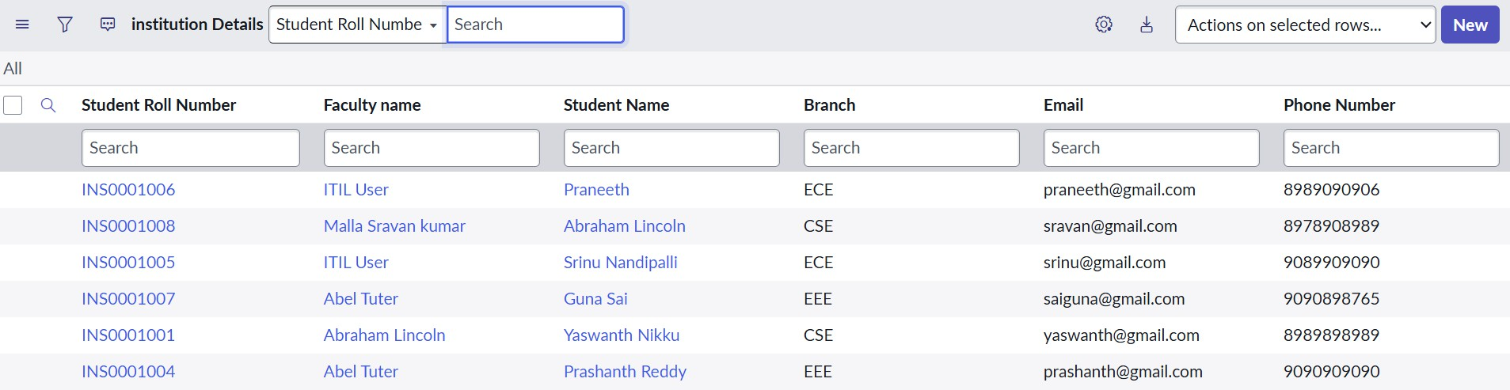
3. | Fine Tunning Result( if Done) | Validation Accuracy - 100%  ACLs were extended from Read to Create (bb2), Write (bb3) and Delete (bb4). A user with bb1–bb4 can view, create, edit and delete EEE branch records. | 